**Department of Systemics**

**School of Computer Science**

University of Petroleum and Energy Studies

cid:image003.png@01D81F60.F8BDA810

**ADVANCE DATABASE MANAGEMENT SYSTEM**

**LAB FILE**

Submitted by

**Akshat Negi**

**R2142220414**

**Batch - 2**

B.Tech Computer Science and Engineering(CSF)

Submitted to

**Dr. KOTHA VENUGOPALCHARY**

Assistant Professor (SS)

SOCS, UPES

**LAB EXPERIMENT – 4**

**Created a Database for Lab 4 Experiment.**

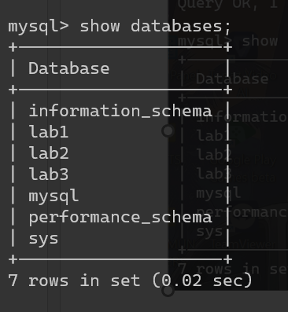

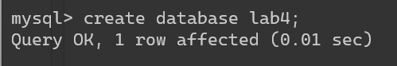

**Select Database for inserting Tables.**



**Creating Table EMP**

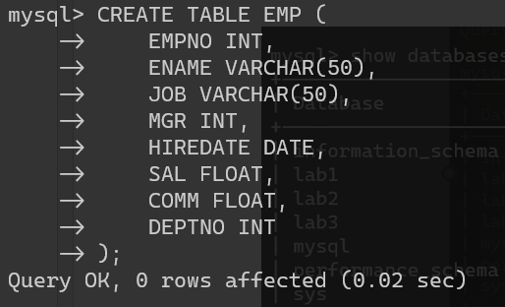

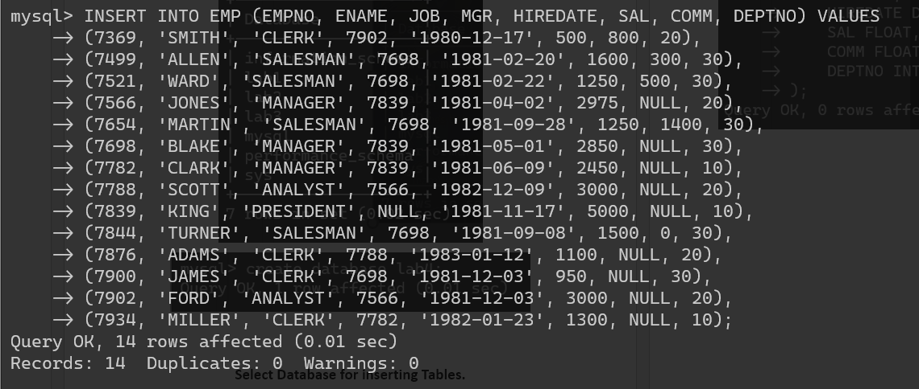

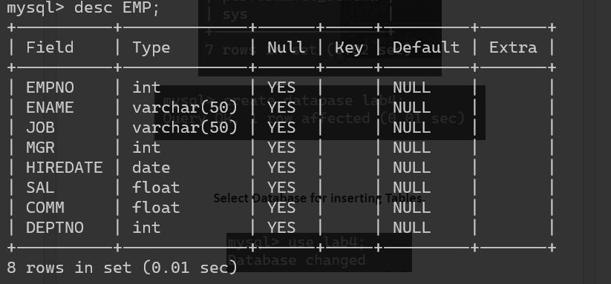

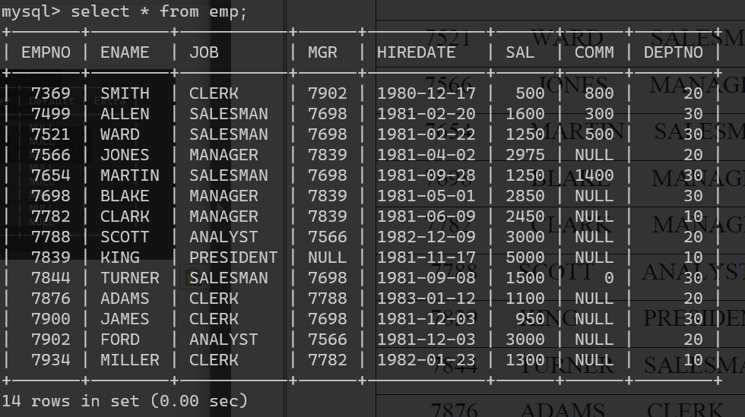

**Creating Table EMP**

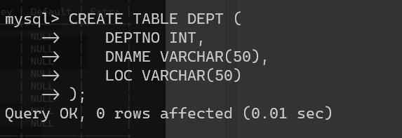

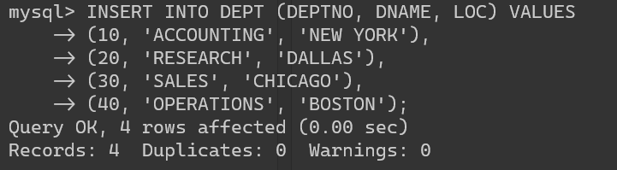

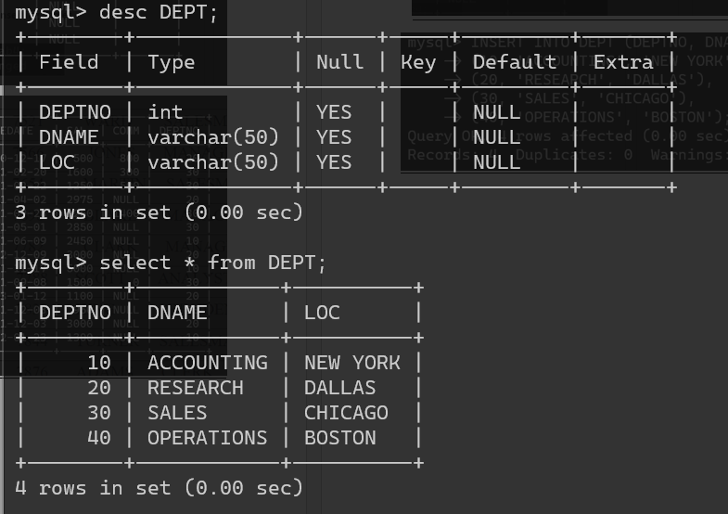

Write the Nested Queries for the following queries.

1. List the details of the emps whose Salaries more than the employee BLAKE.

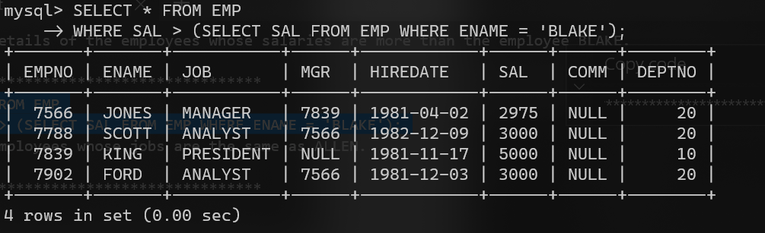

1. List the emps whose Jobs are same as ALLEN.

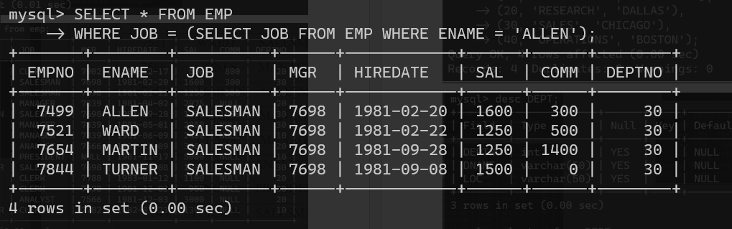

1. List the Emps whose Sal is same as FORD or SMITH in desc order of Names.

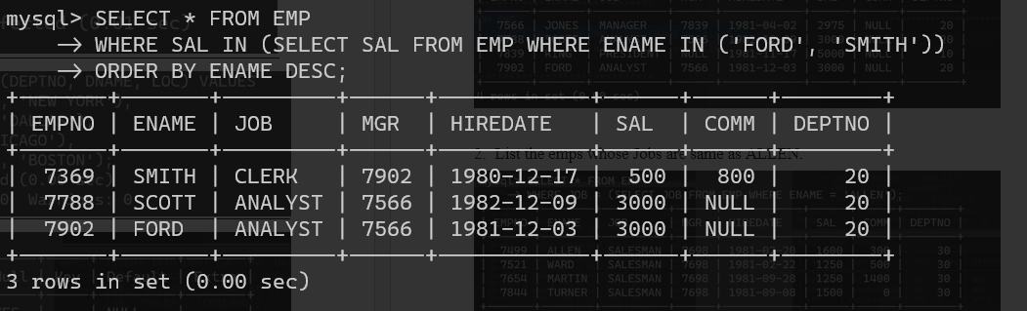

1. List the emps Whose Jobs are same as MILLER or Sal is more than ALLEN.

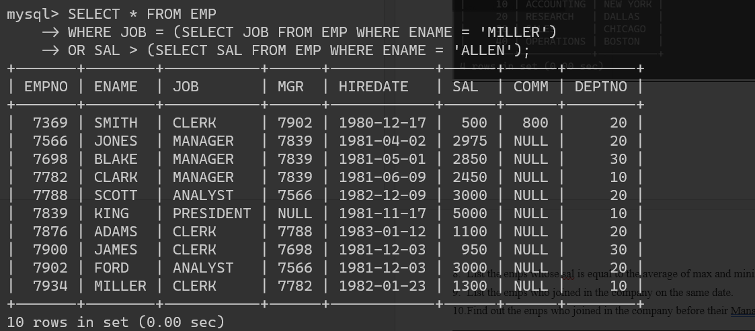

1. Find the highest paid employee of sales department.

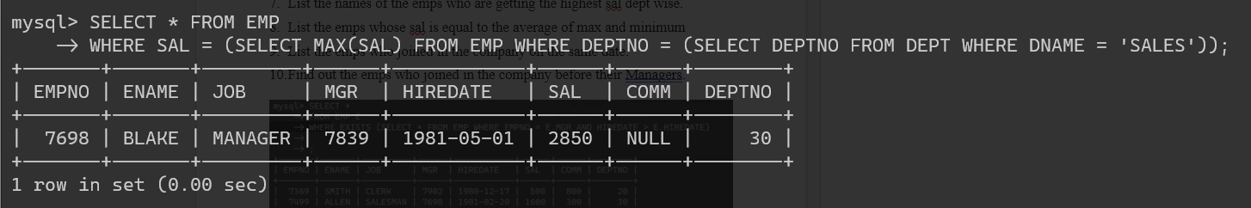

1. List the employees who are senior to most recently hired employee working under king.

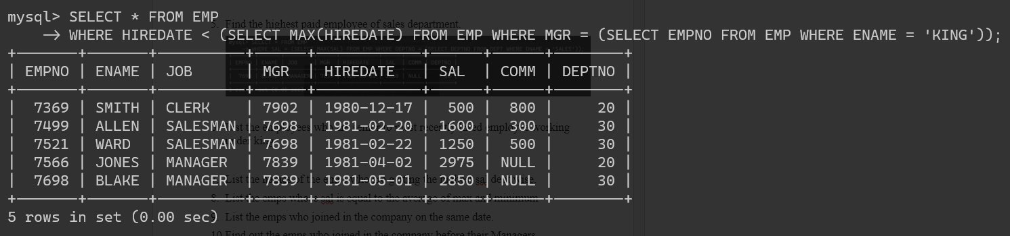

1. List the names of the emps who are getting the highest sal dept wise.

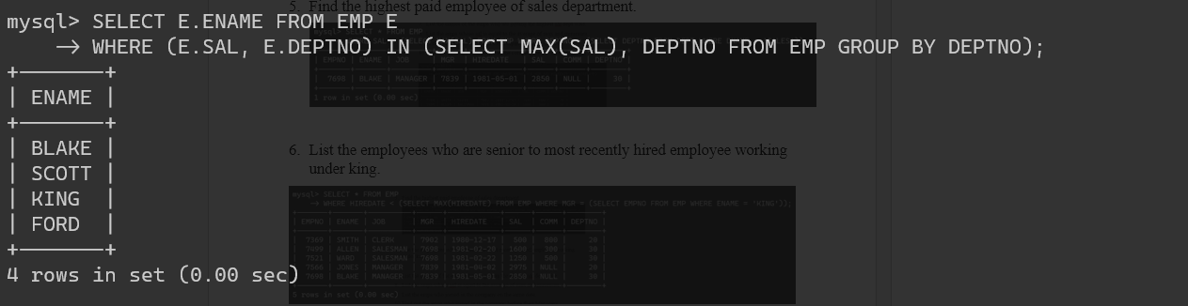

1. List the emps whose sal is equal to the average of max and minimum

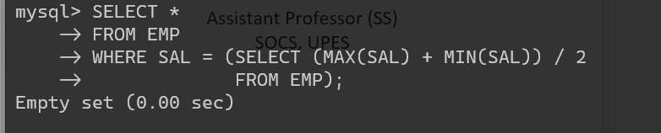

1. List the emps who joined in the company on the same date.

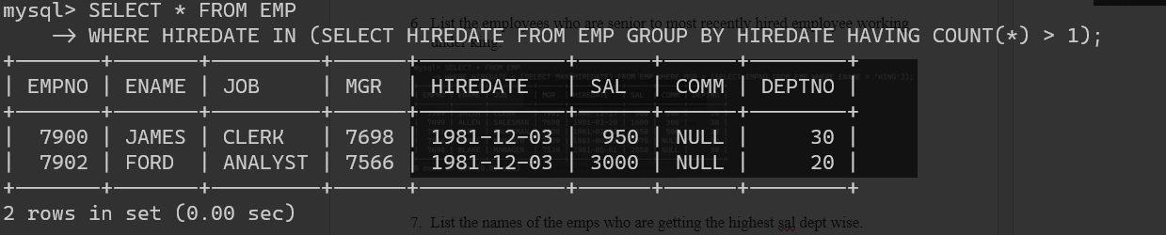

1. Find out the emps who joined in the company before their Managers.

